**Caribbean & Mexico**

5* Jamaica From £1,310pp 4* Barbados – 7 nights – All Inclusive From £1,699pp

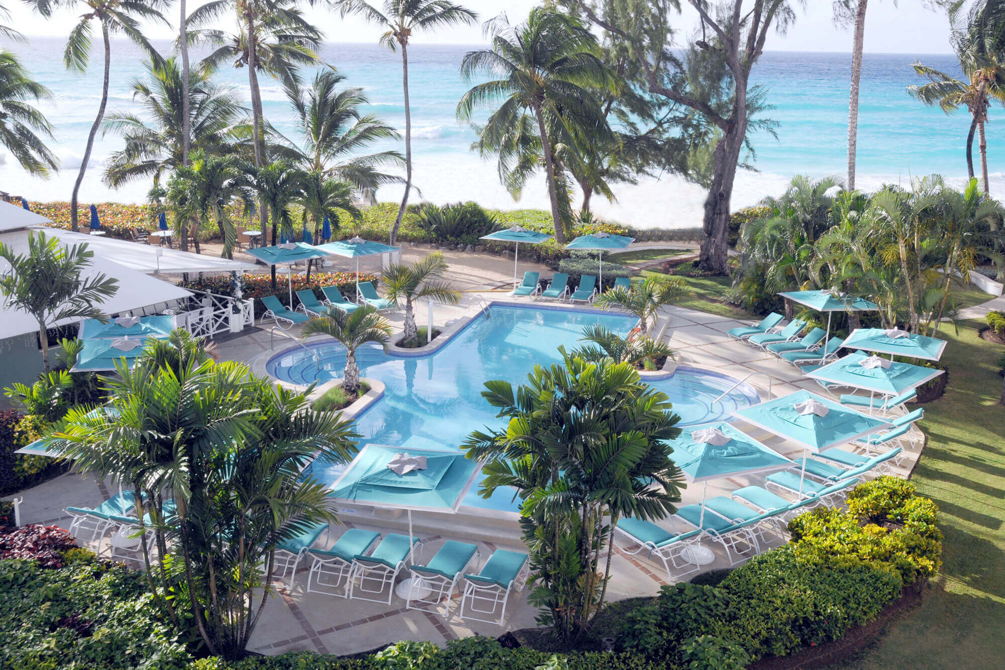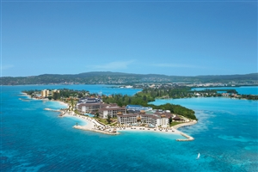

5* St Lucia From £1,310pp 5* Mexico – All Inclusive From £949pp

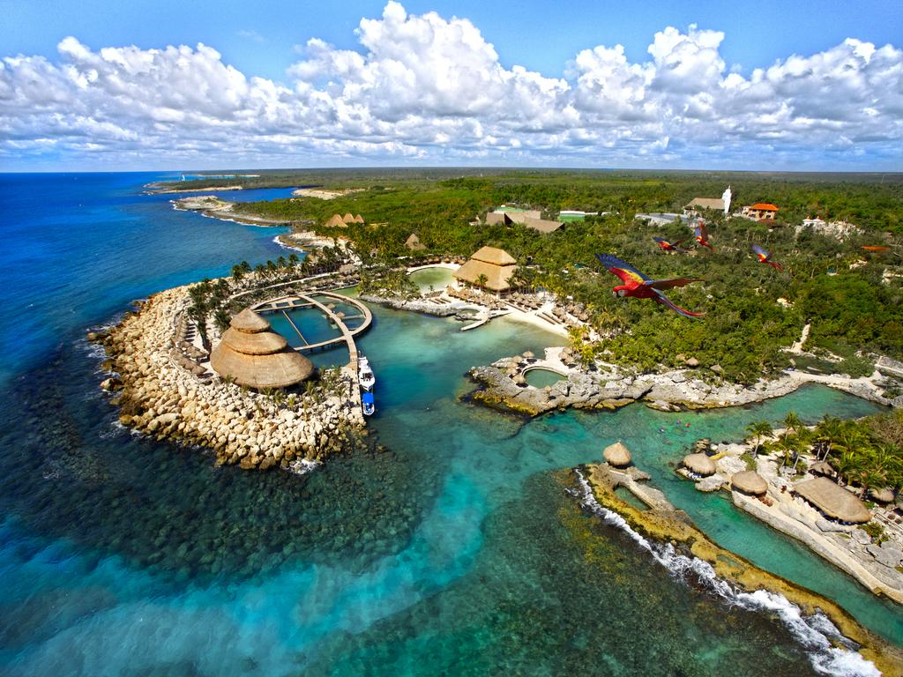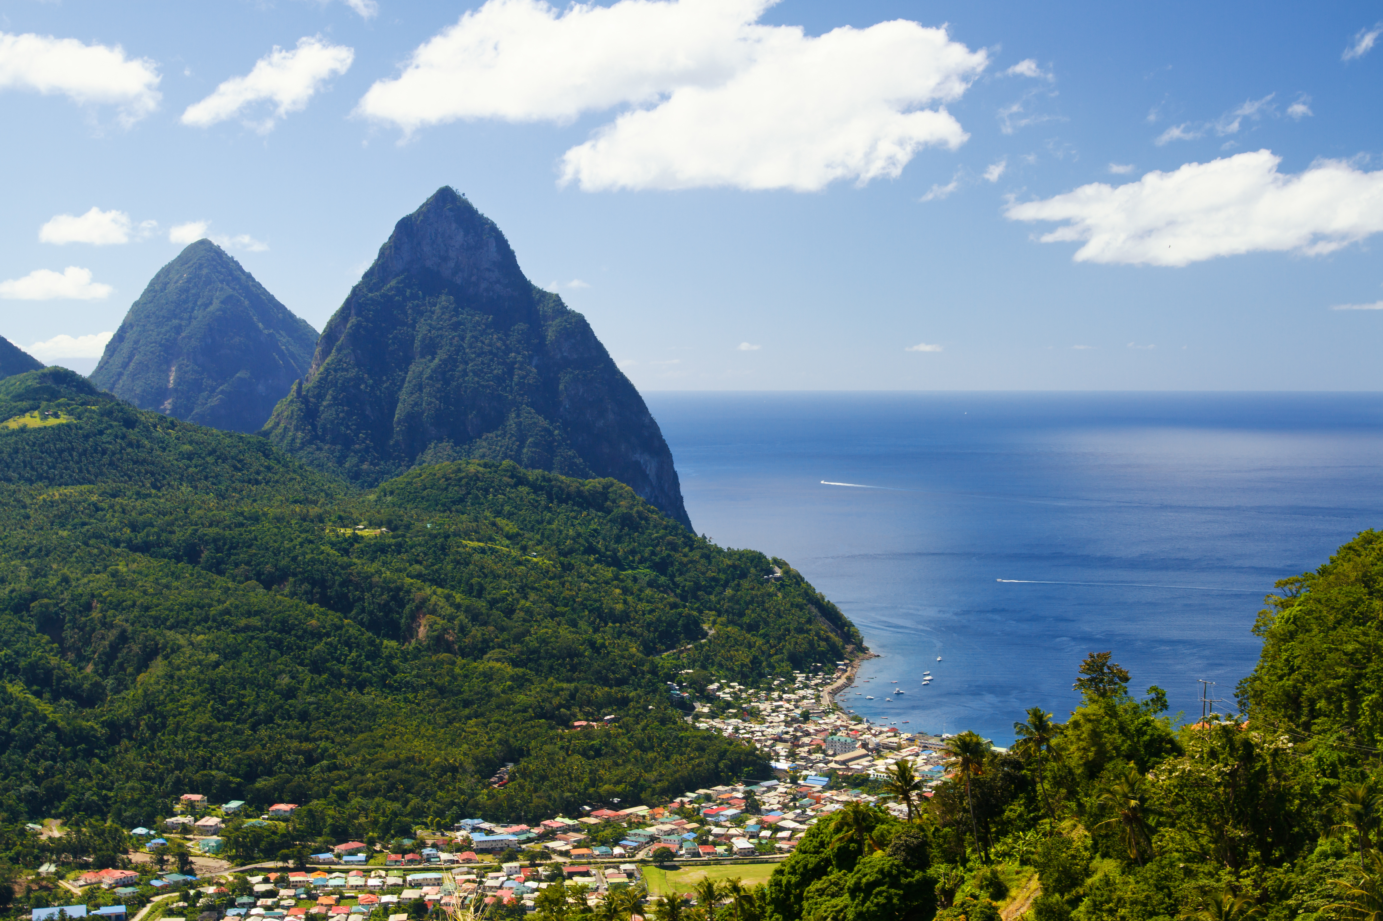

5* Grenada – All Inclusive From £2,769pp 4* Antigua – All Inclusive From £1,859pp

